

MUHAMMAD MUDASSAR ANWAR

CMS ID 456925

ME-15 SEC-A

CS-114

26 OCT 2023

TASK 1:

#include <iostream>

using namespace std;

int main(){

for(int count=1; count<=150; count++){

if(count%10==0){

continue;

}

else{

cout<<count<<", ";

}

}

return 0;

}

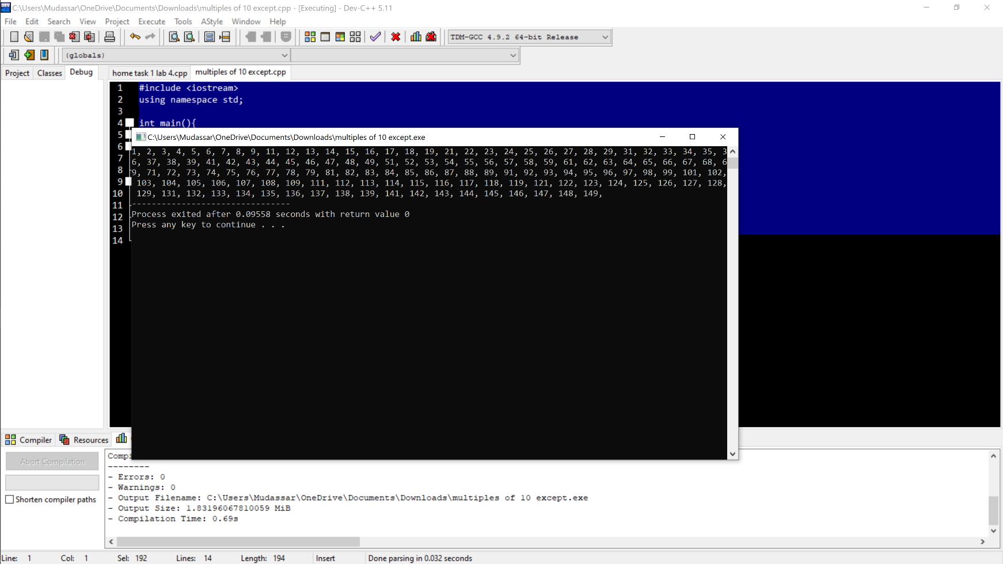

TASK 2:

#include<iostream>

using namespace std;

int main()

{

int x,sum=0;

cout<<"enter the number";

cin>>x;

while(x>0){

sum=sum+(x%10);

x=x/10;

}cout<<"sum is "<<sum<<endl;

return 0;

}

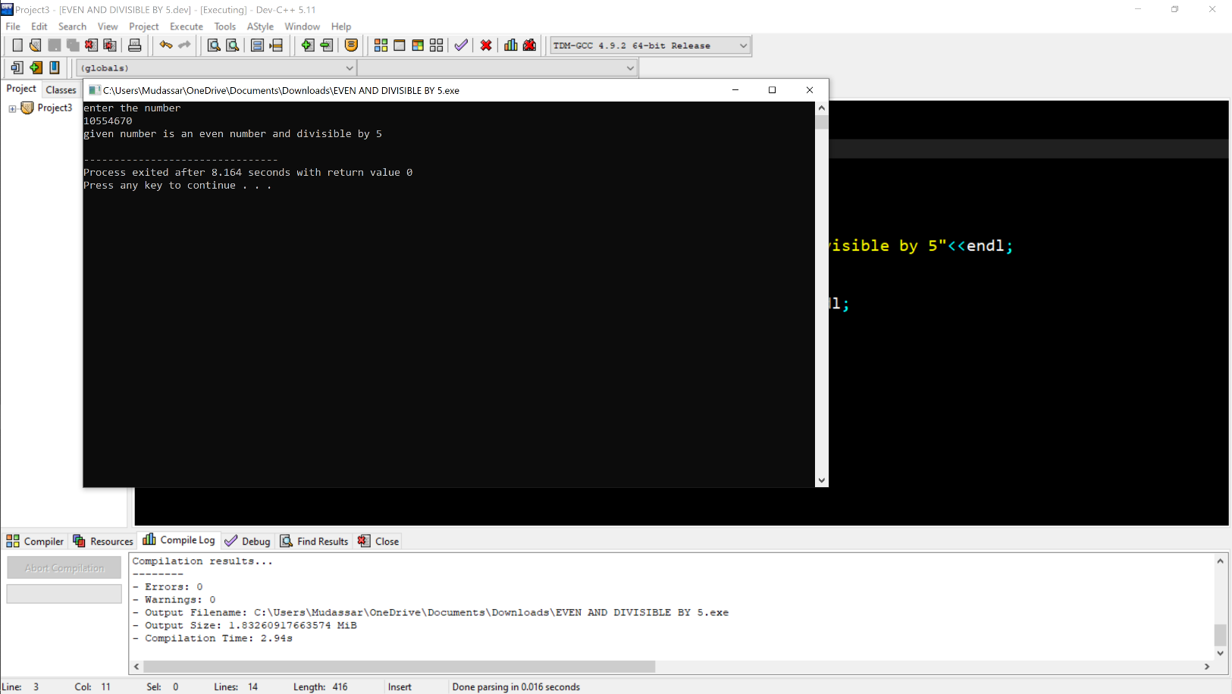

TASK 3:

#include<iostream>

using namespace std;

int main()

{

int x;

int z=0;

cout<< " Plz tell a number: ";

cin>>x;

for(int y=1;y<=x;y++)

{

if(x%y==0){

z++;

}

}

if(z==2)

{

cout<<" The number is a prime number ";

}

else {

cout<<"The number is not a prime number";

}

return 0;}

